Task for ASG
- Create one VPC in N. Virginia region.

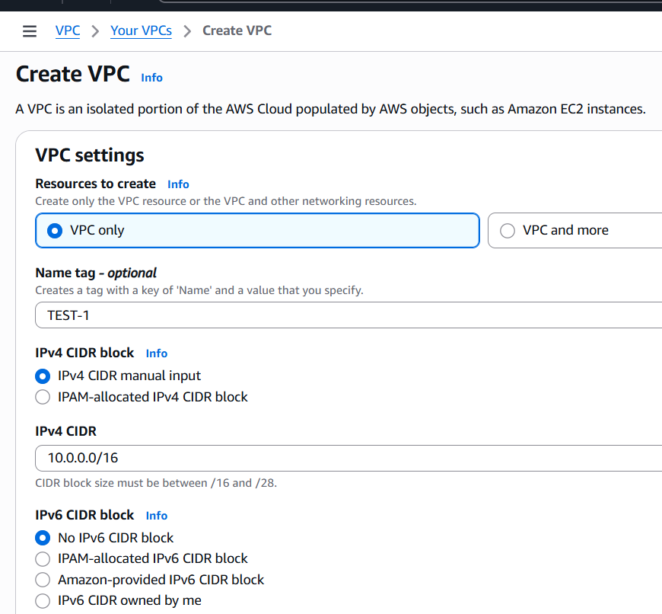

- Create two subnets: one public subnet and one private subnet.
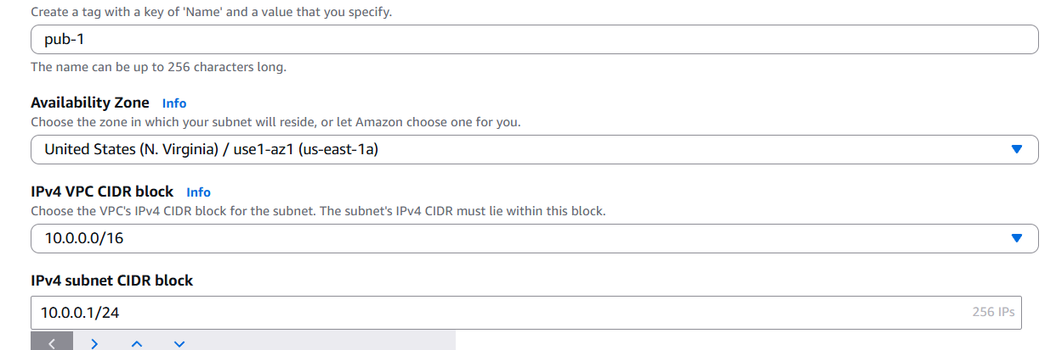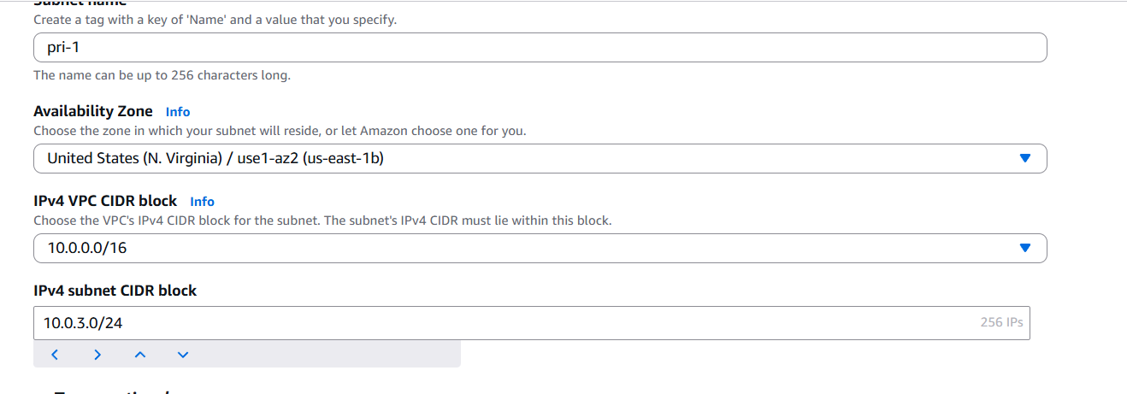
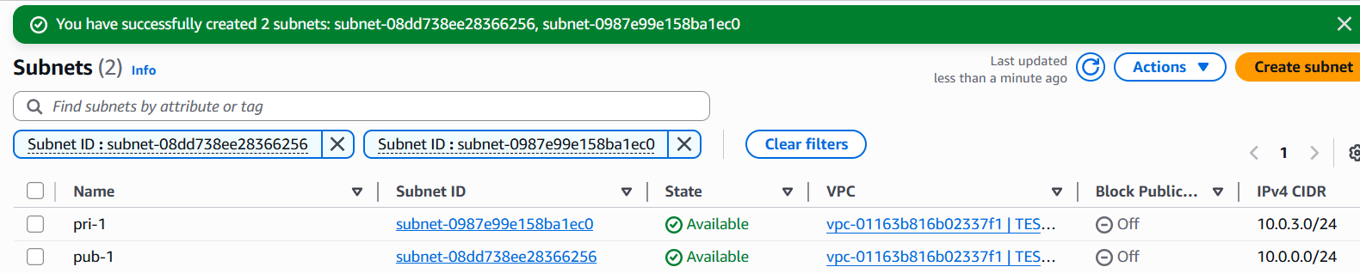
- Attach an IGW to the VPC.

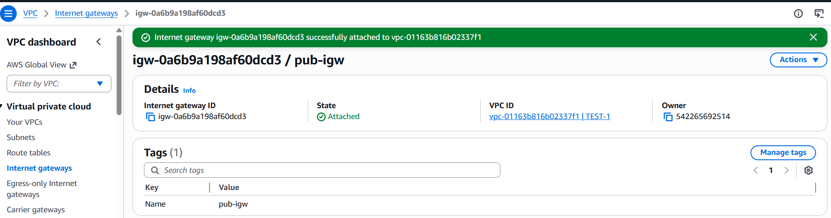
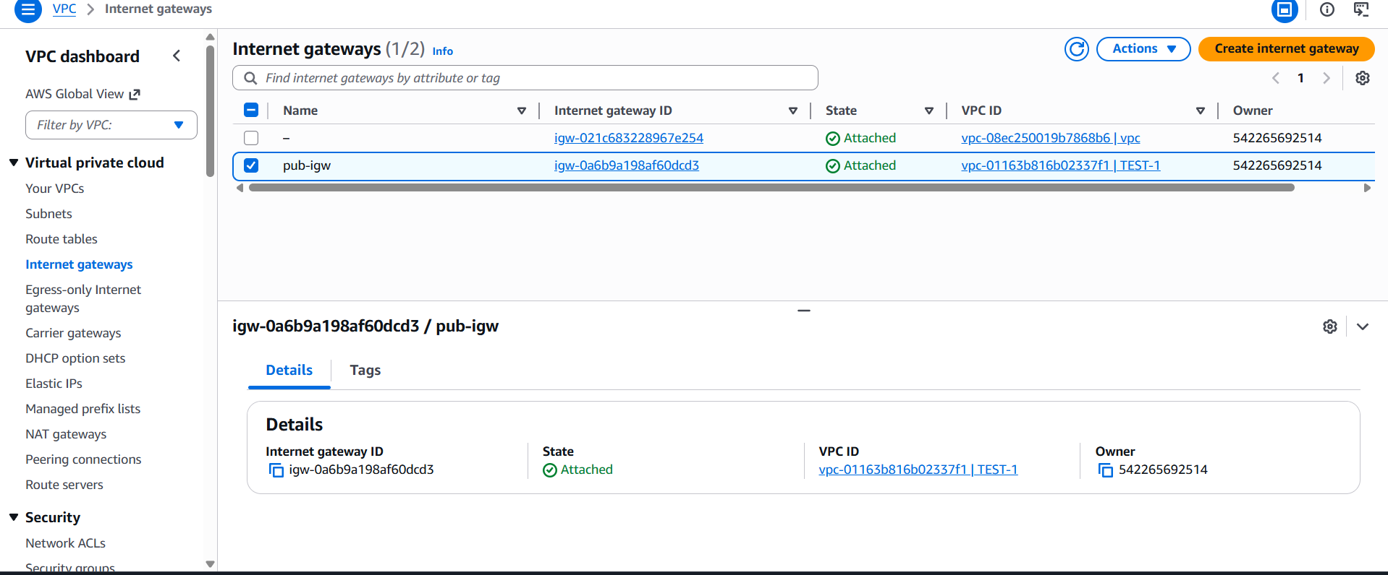
- Create one public route table (RT) and one private route table.

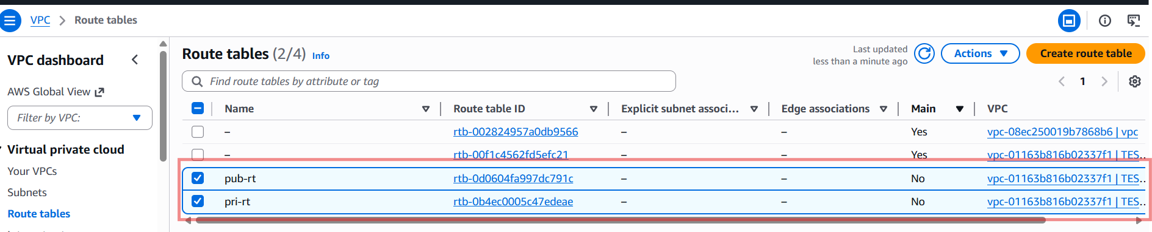
- Deploy a NAT gateway in the public subnet and attach the NAT gateway to the private subnet.
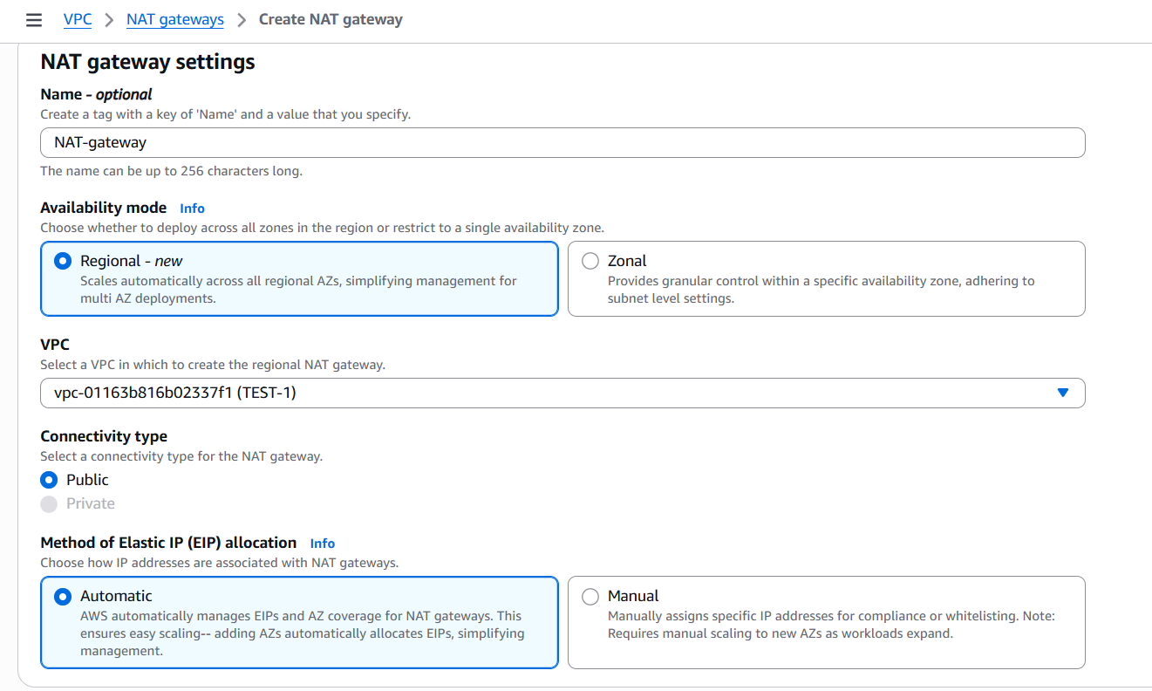

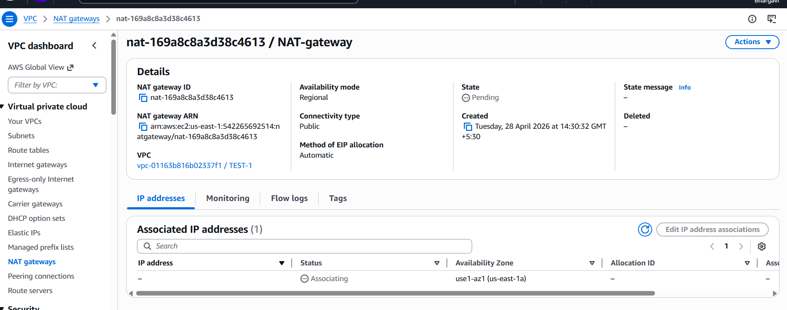
Create nat gateway with public subnet successfullyconnect this in route table in private subnet connect ngw
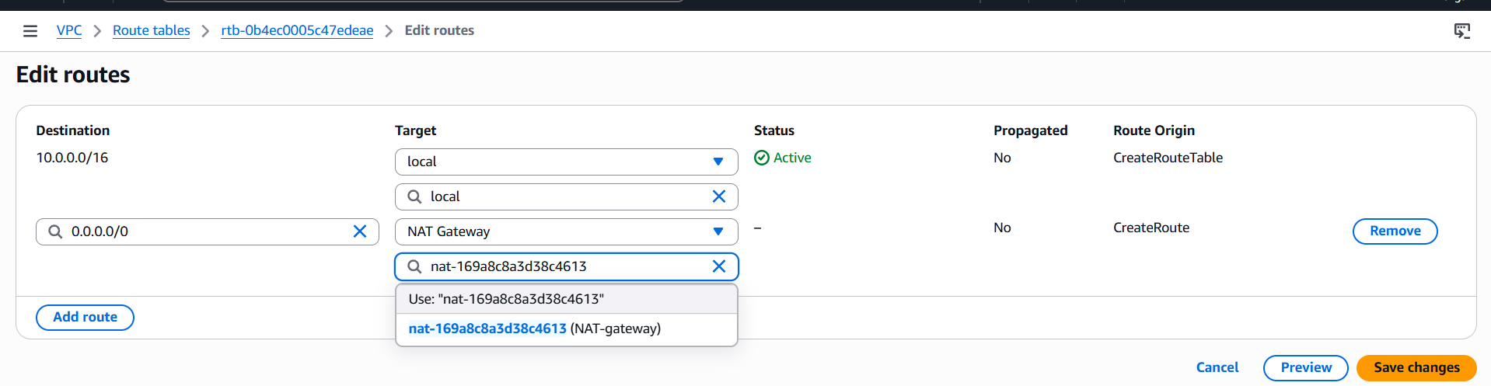
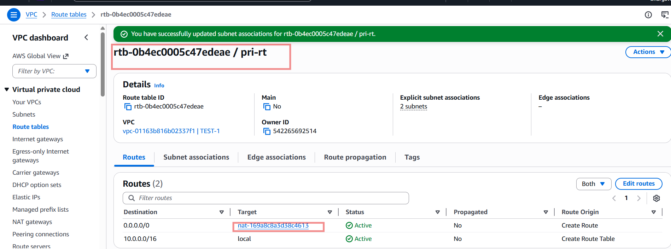
- Create two instances, one in the public subnet and one in the private subnet.
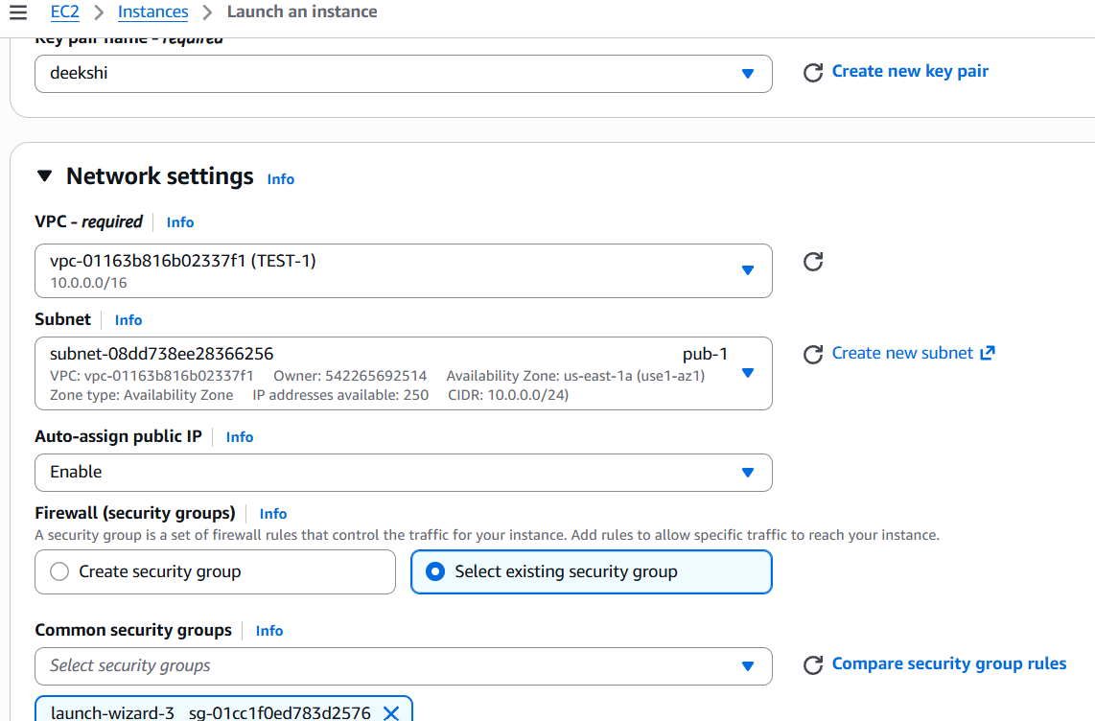
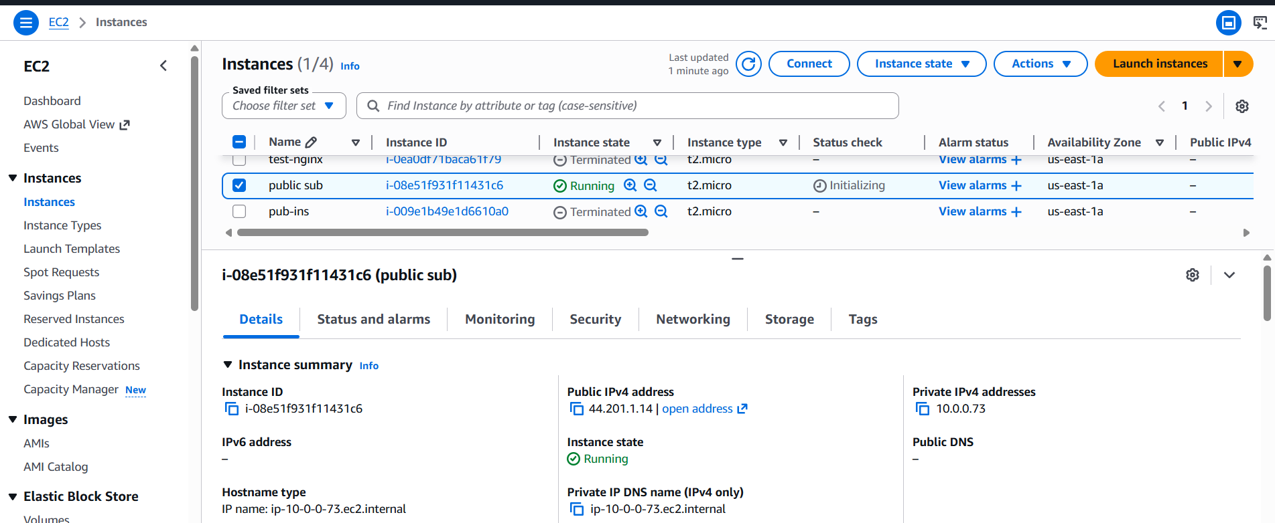

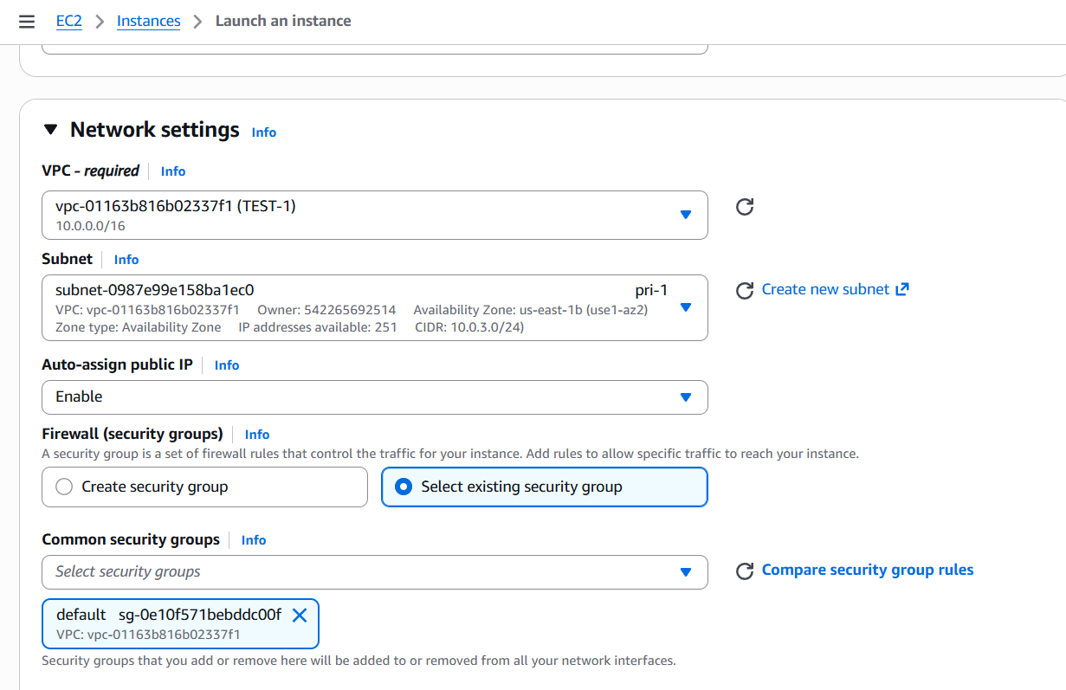
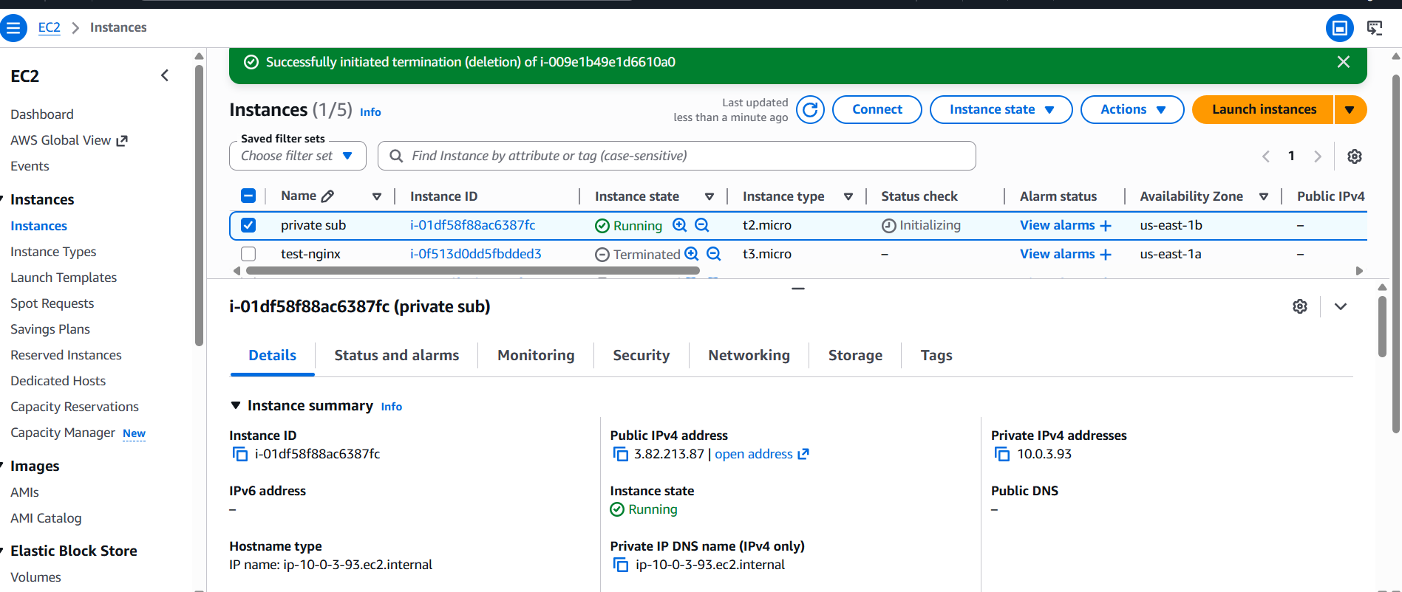

- Deploy Apache server on both EC2 instances with a sample index.html file.
public instance connect pem key to git bash 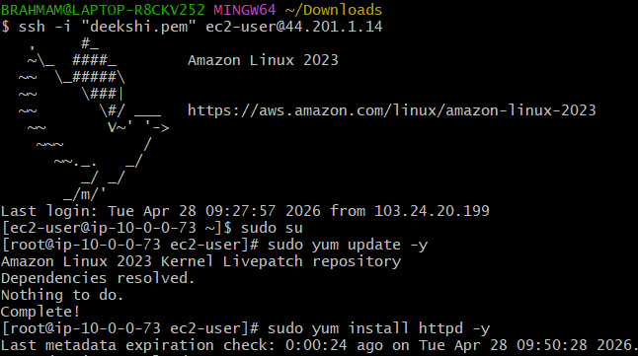
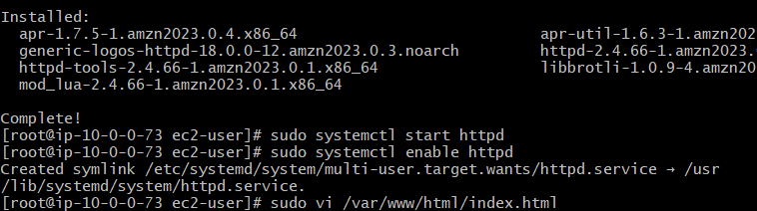
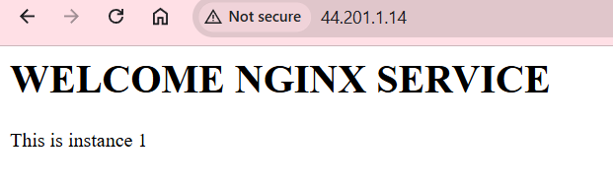
git bash downloads (cat deekshi.pem)
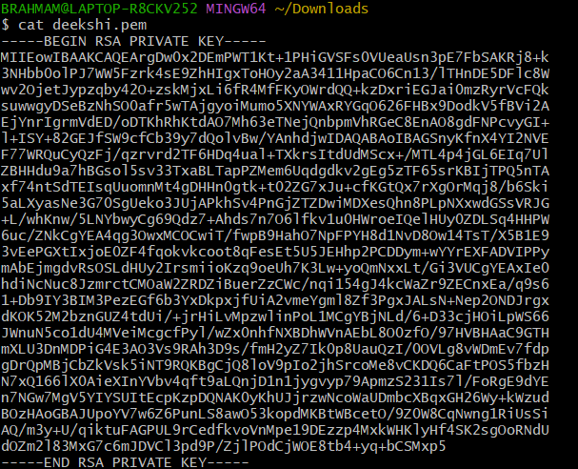copy this paste in this below
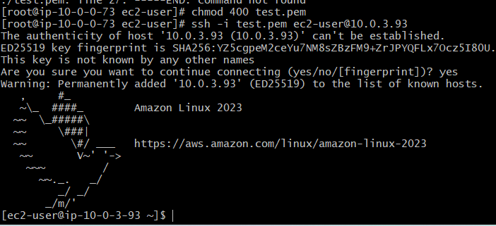
Now we don’t see index.html in private ip
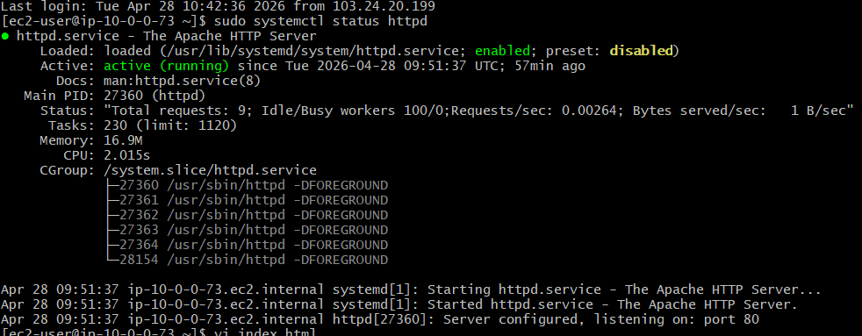
- Create one application load balancer and attach it to both EC2 instances.
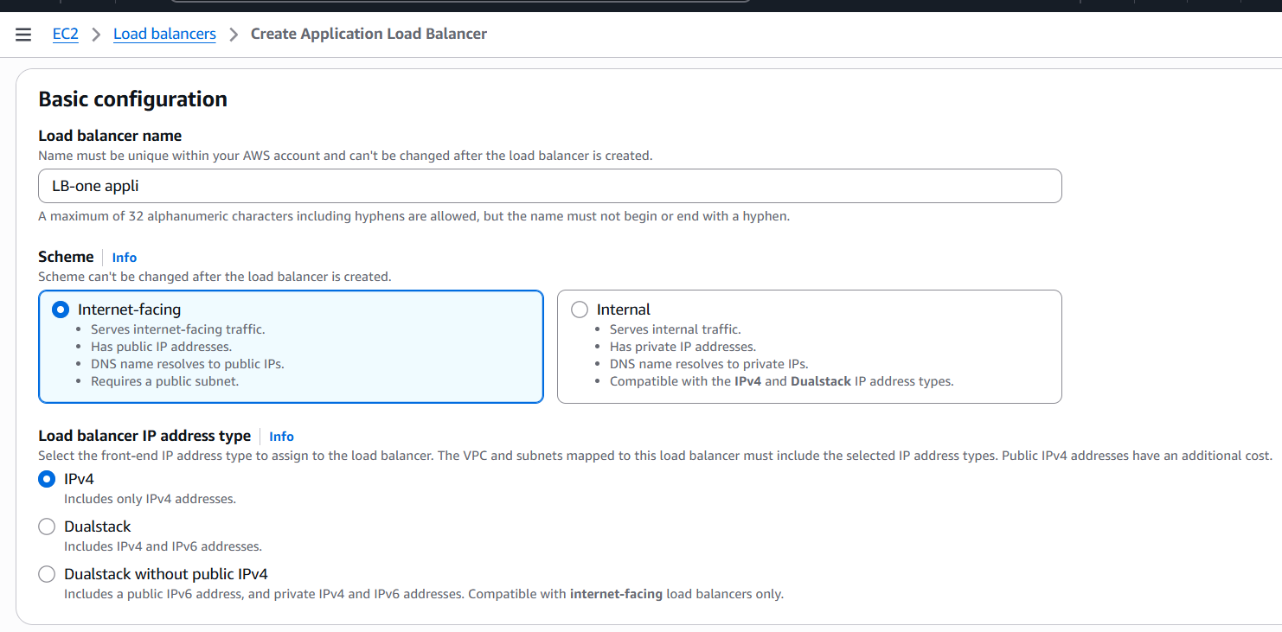
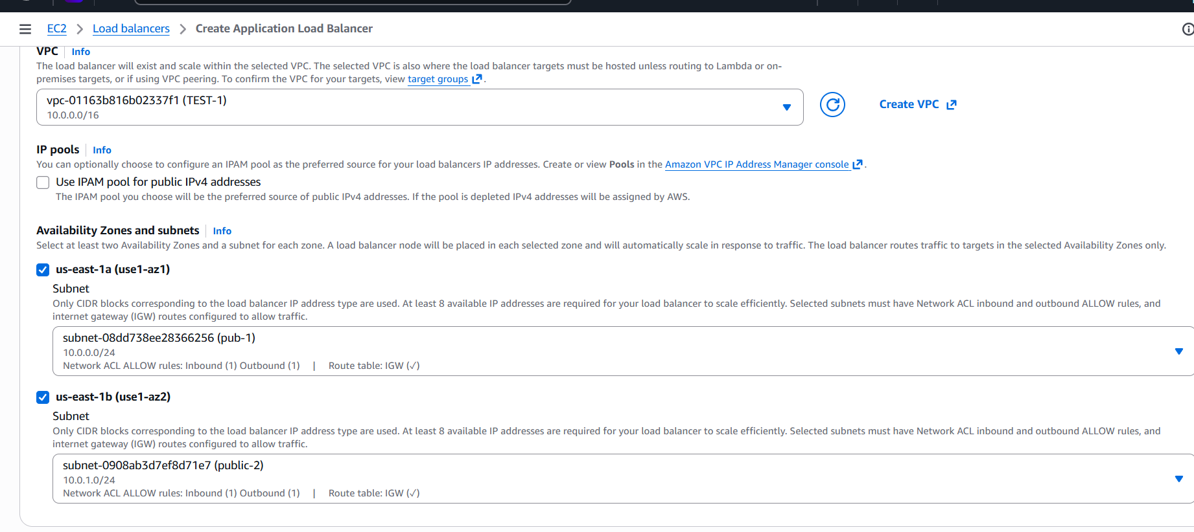
- Create target groups in ec2 instance go to last
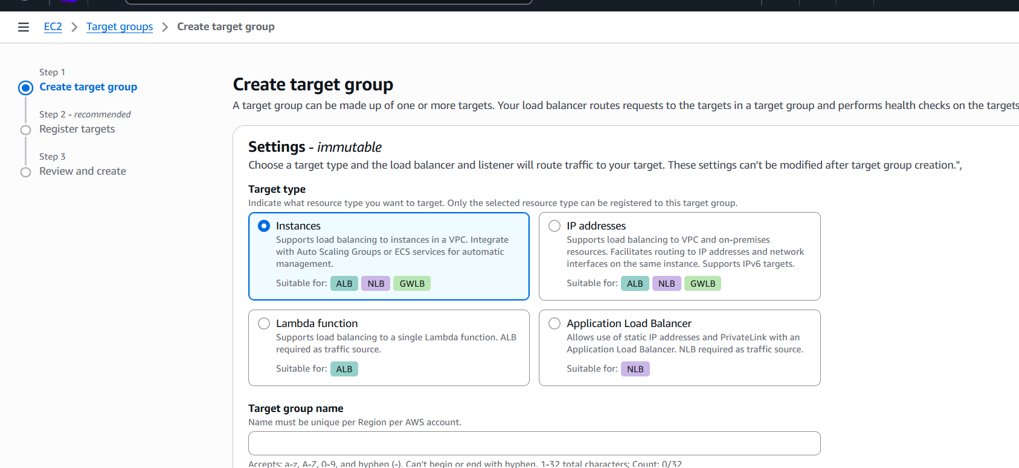
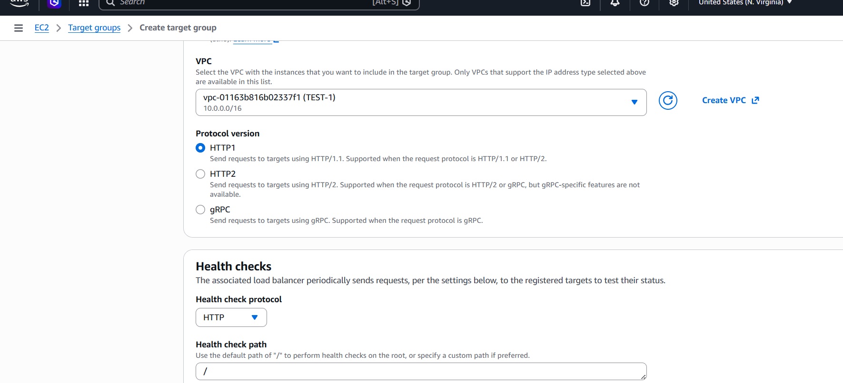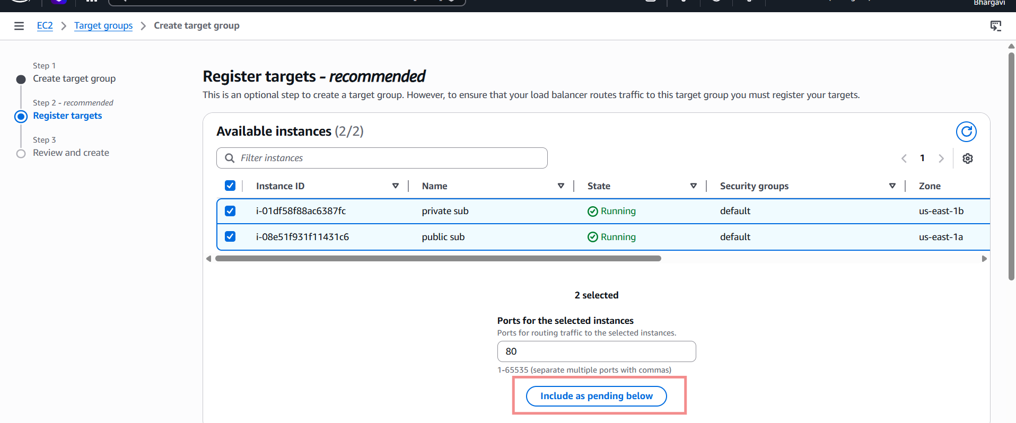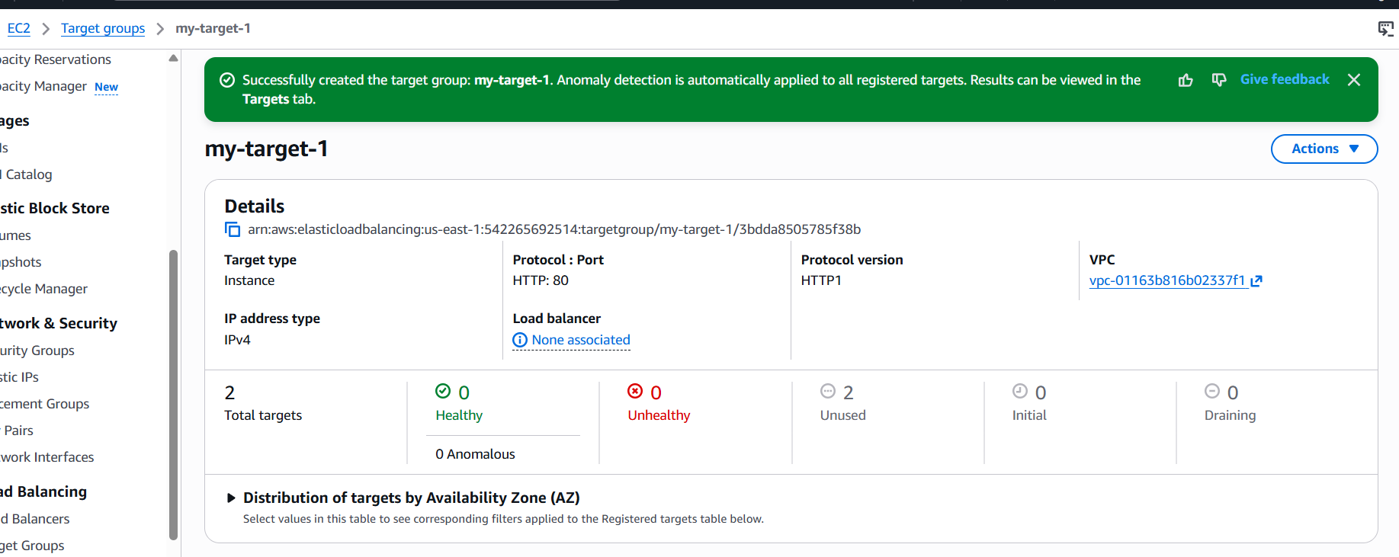
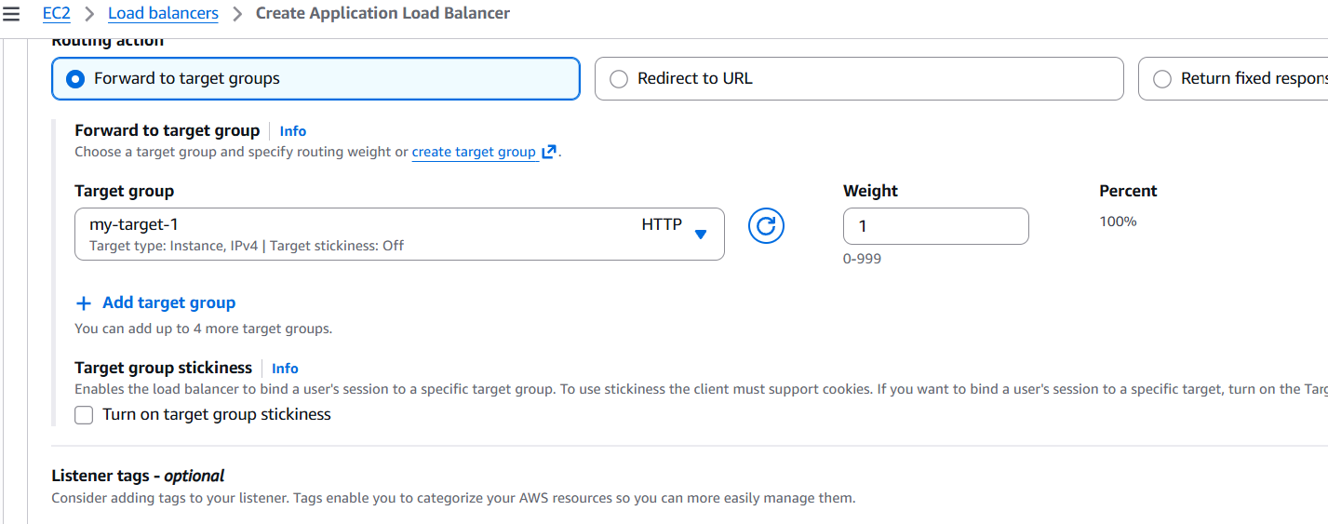
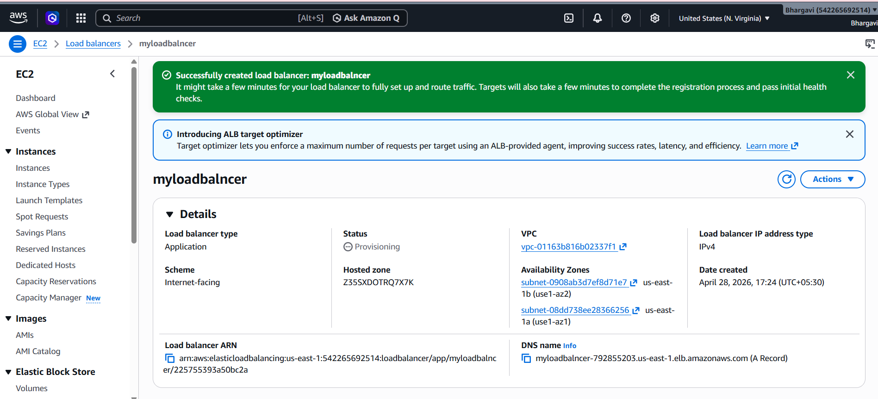
- Attach those ec2 instance in target groups
- Store application load balancer logs in S3.
Go to s3create bucketmy-apl-log-bucket
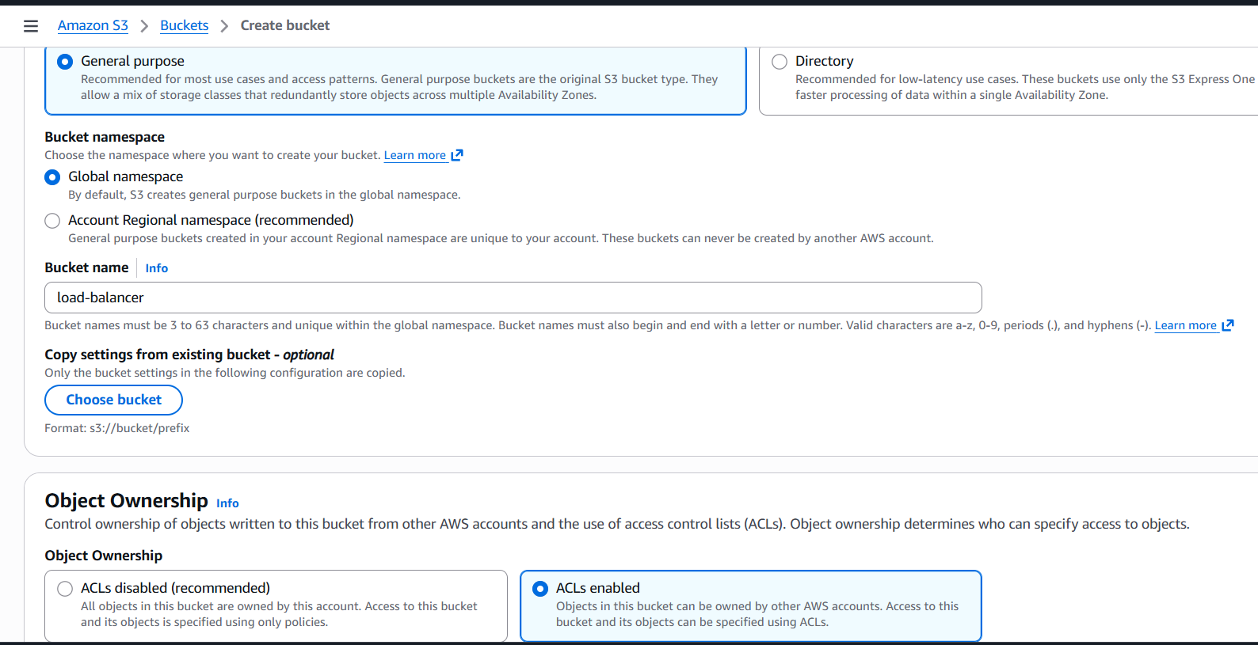
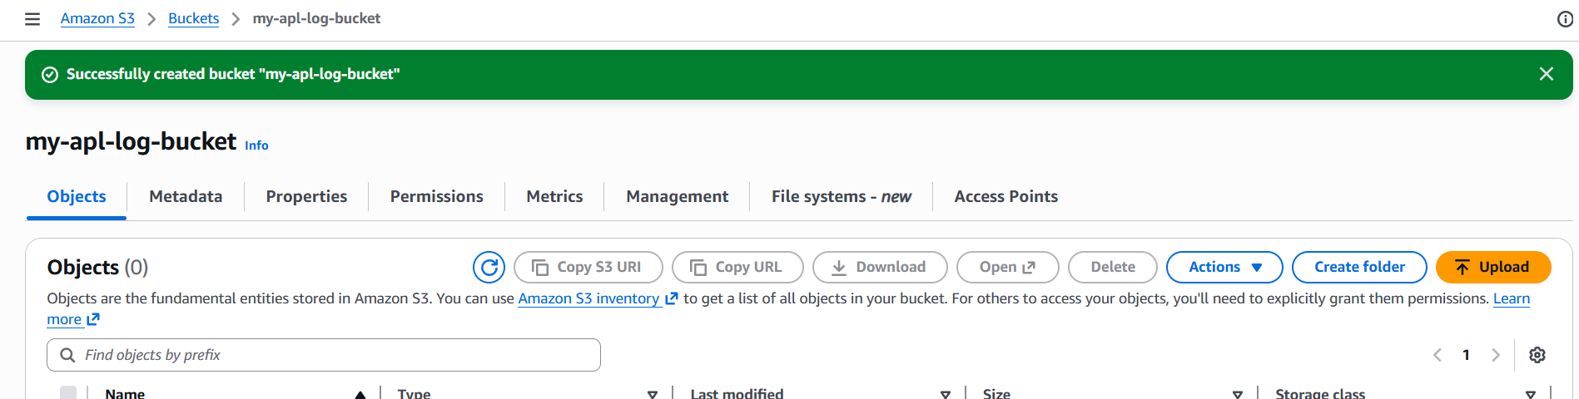
after creating go s3 bucket permissions and add below script
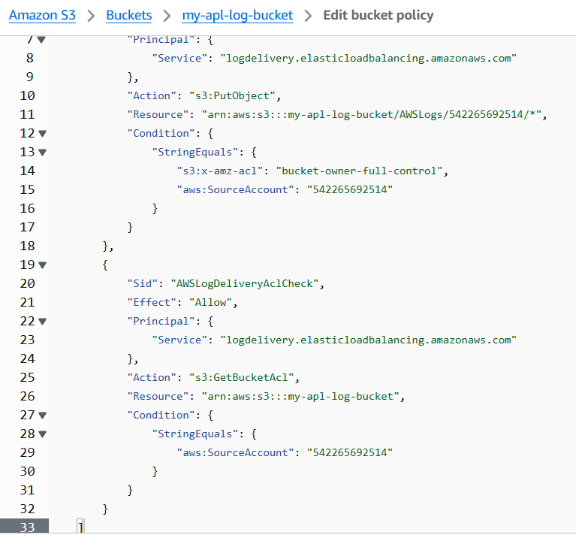
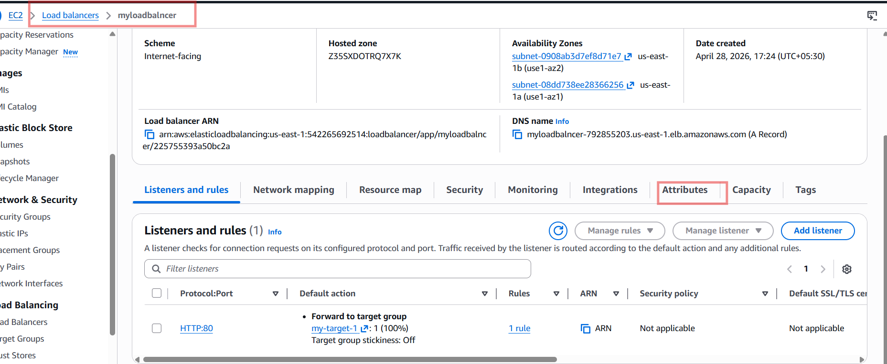
Give the monitoringacess logs choose bucket policy
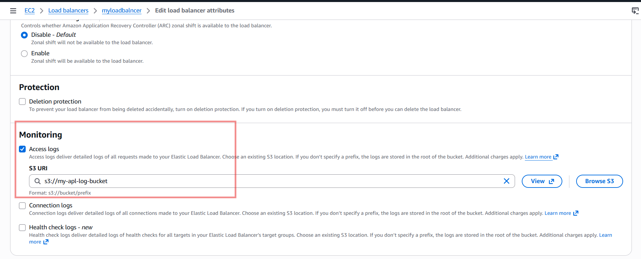
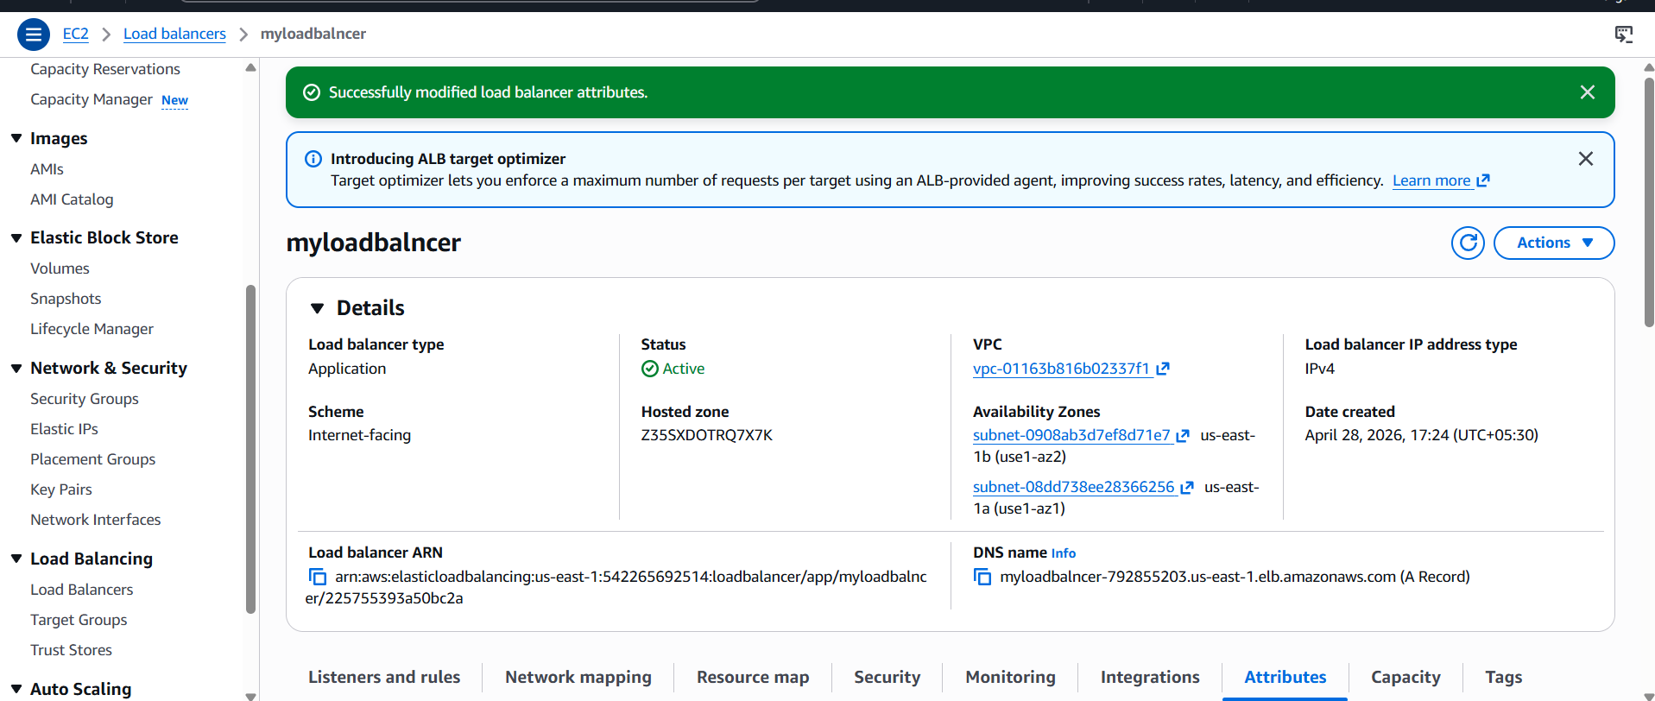

- Store the VPC flow logs in a CloudWatch log group.
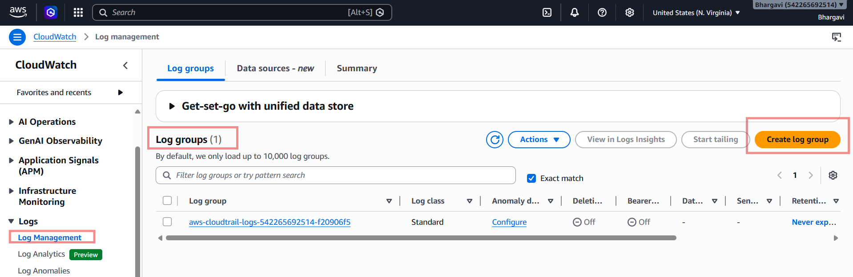
-- Choose VPC → Click Next
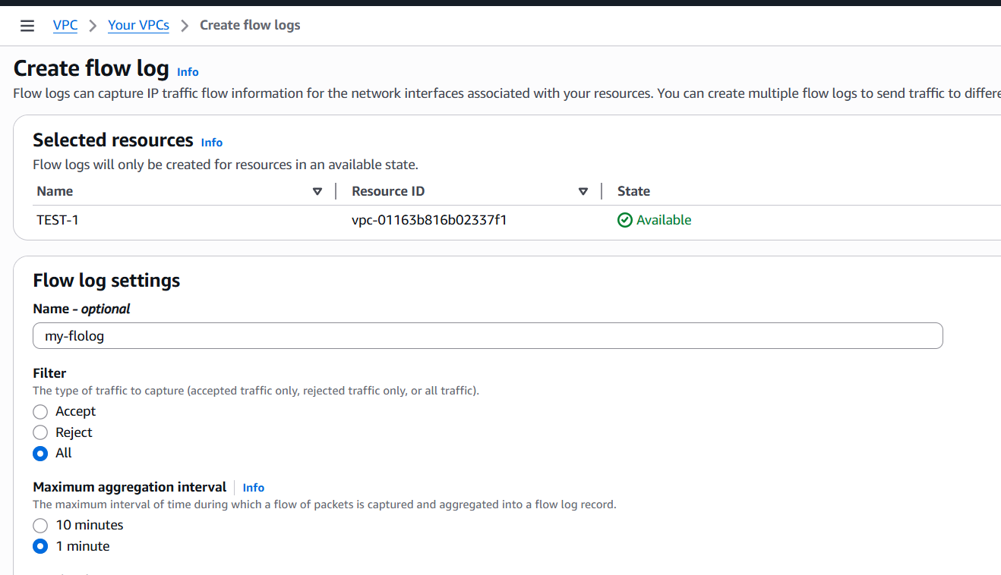
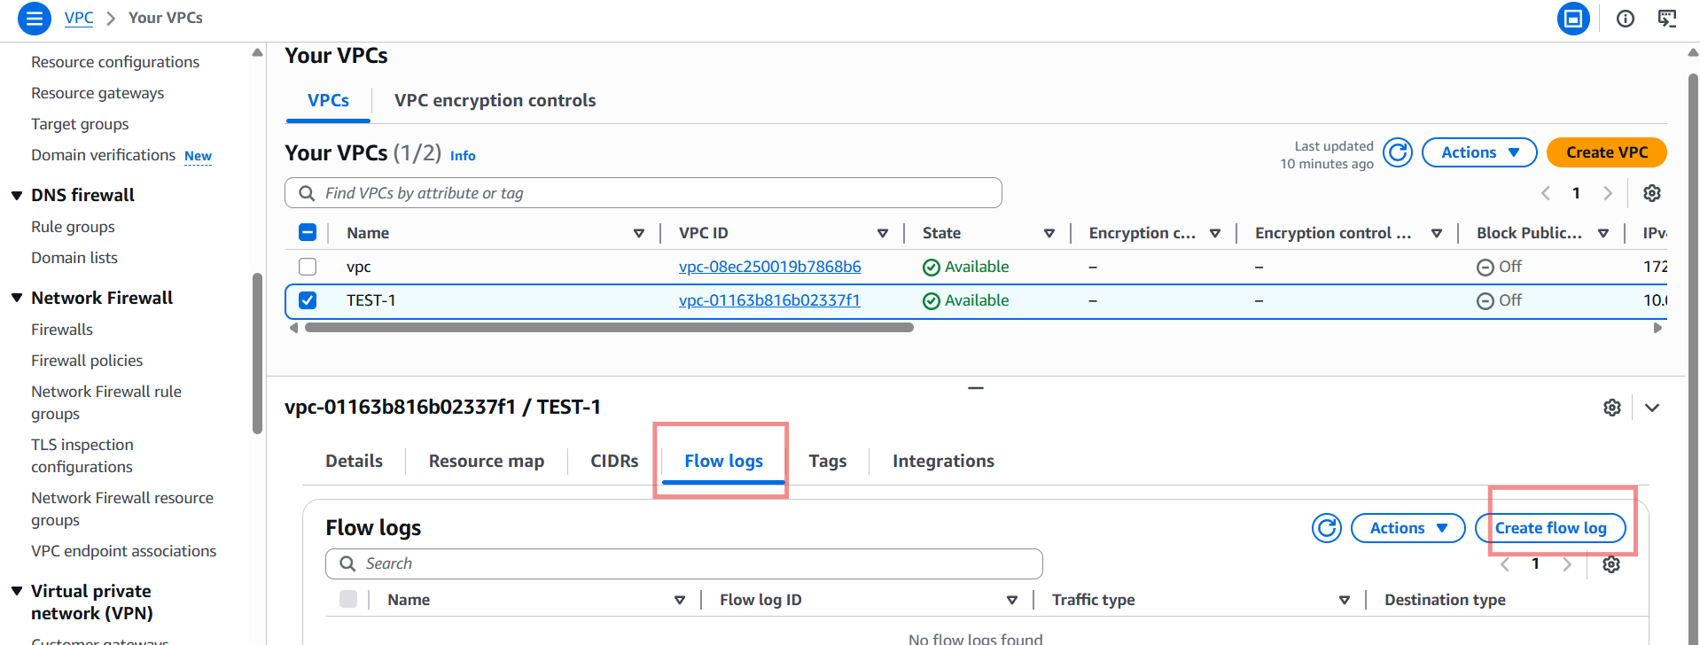

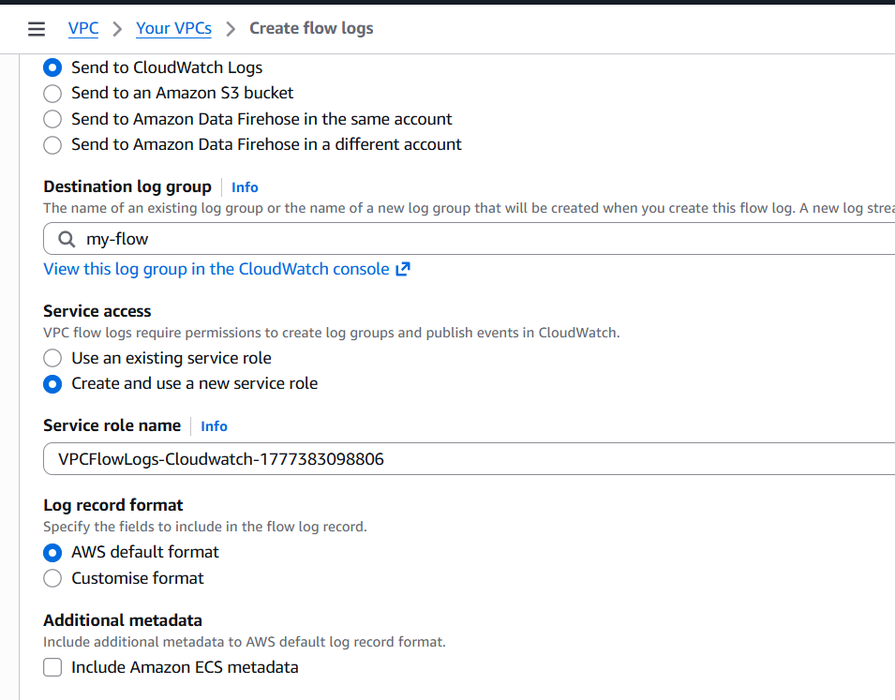

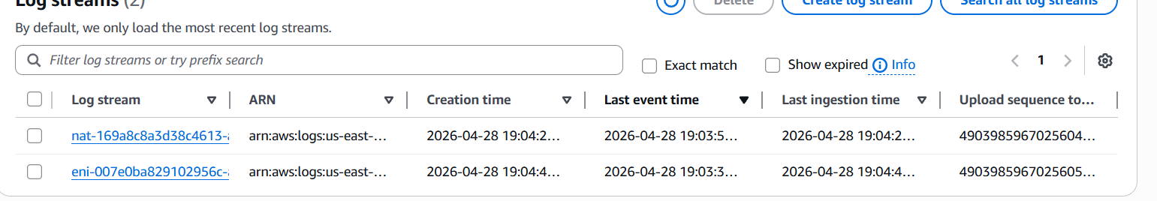

- Create monitoring dashboards to monitor CPU utilization and to monitor the Apache service.
- Go to CloudWatch → Dashboards
- Click Create dashboard
- Enter name: EC2-Monitoring-Dashboard
- Click Create dashboard
Dashboard create dashboard number ec2 pre metrics ec2 instance id cpu
utilization
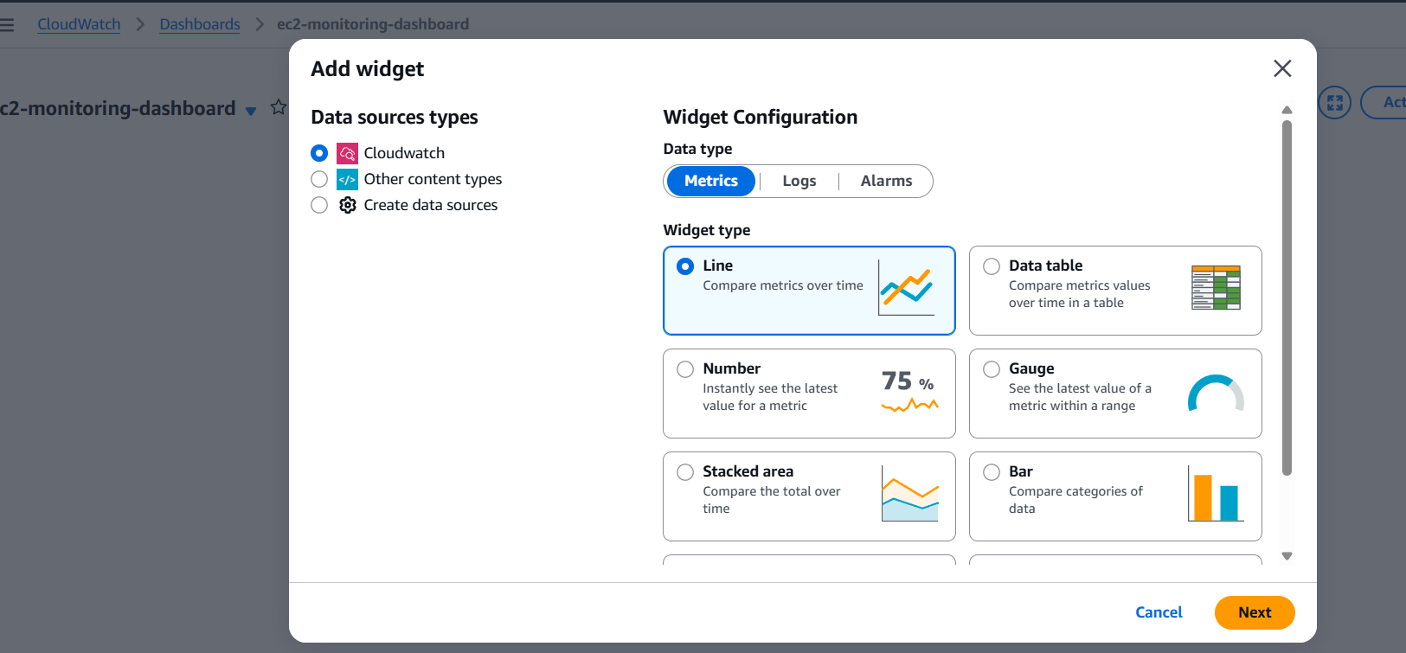
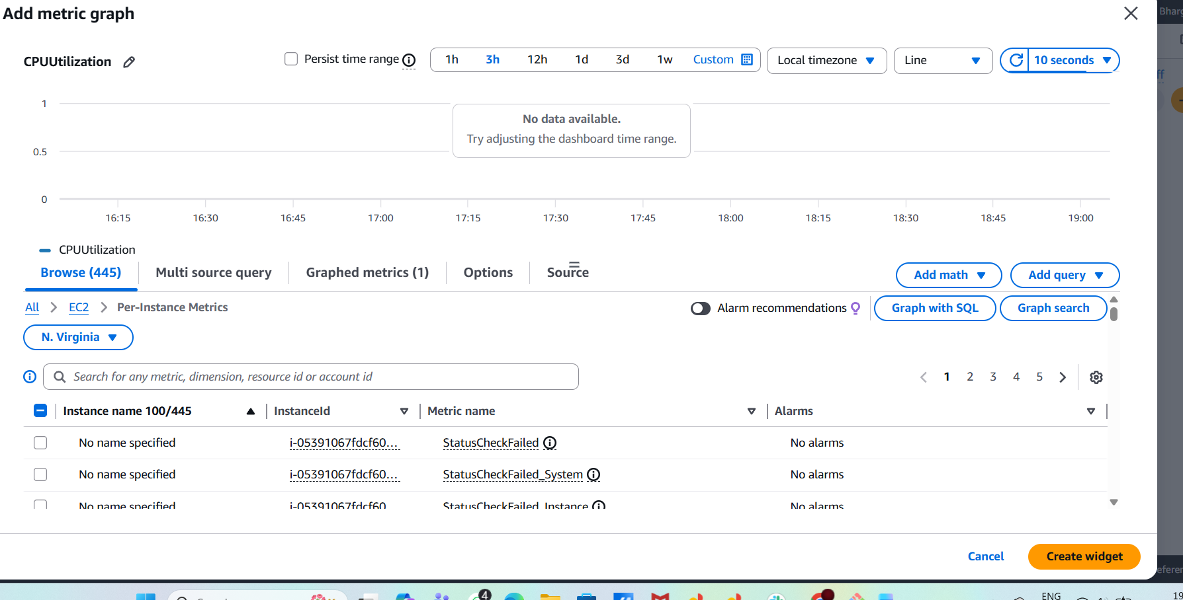
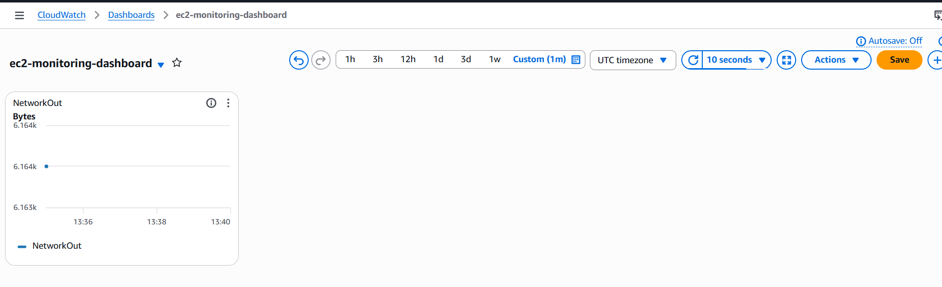
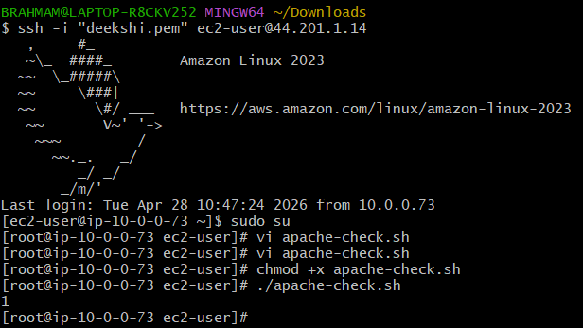
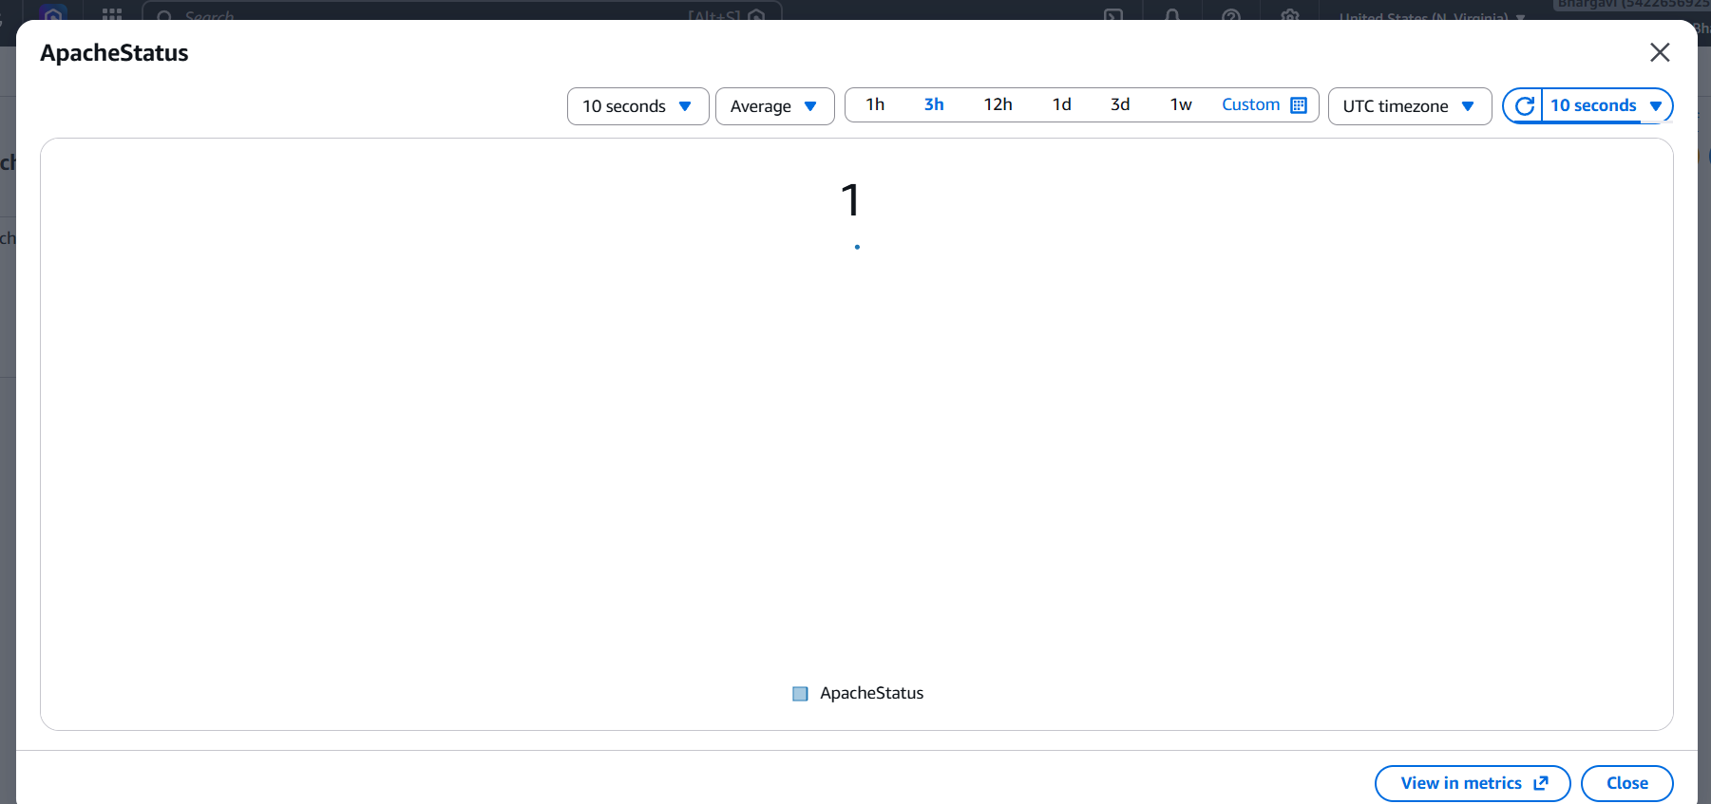
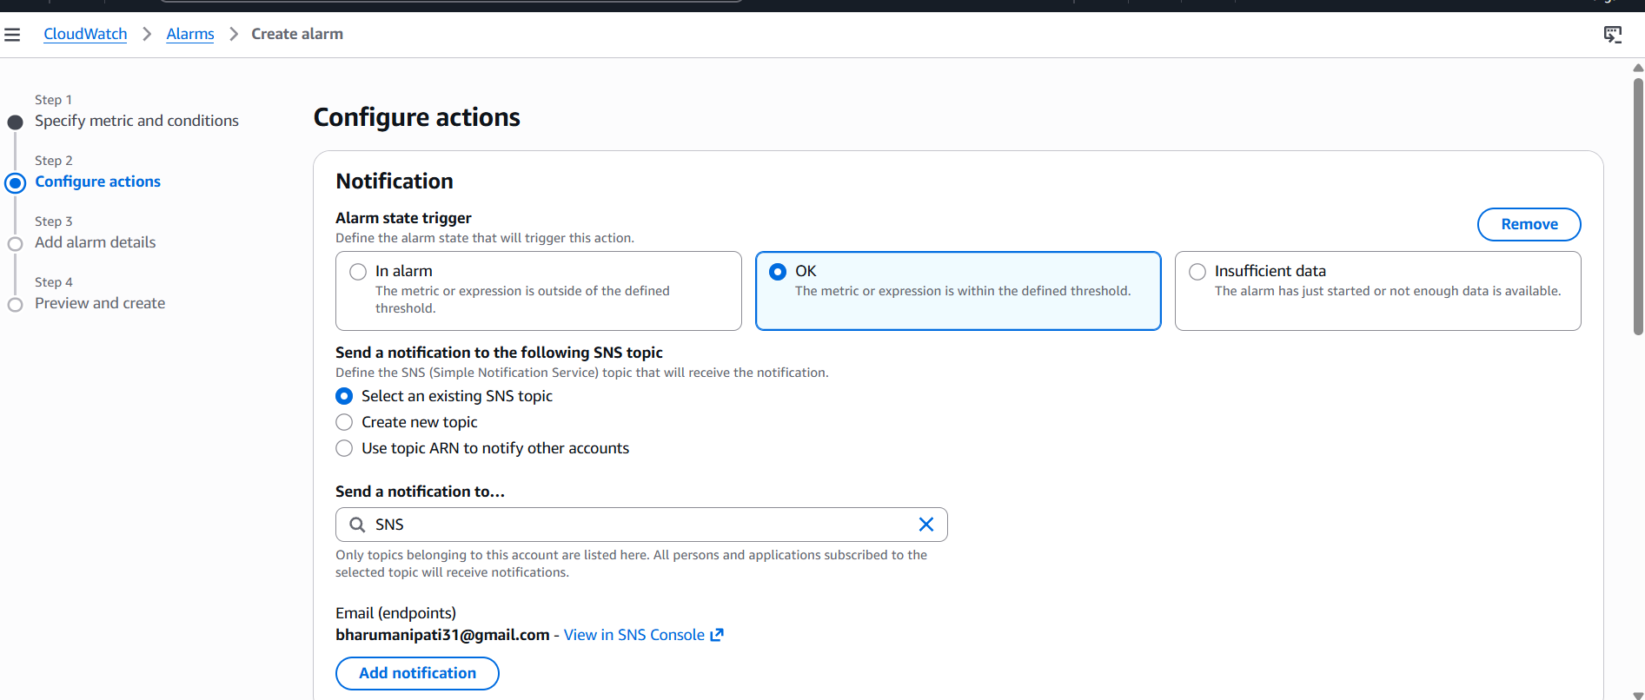
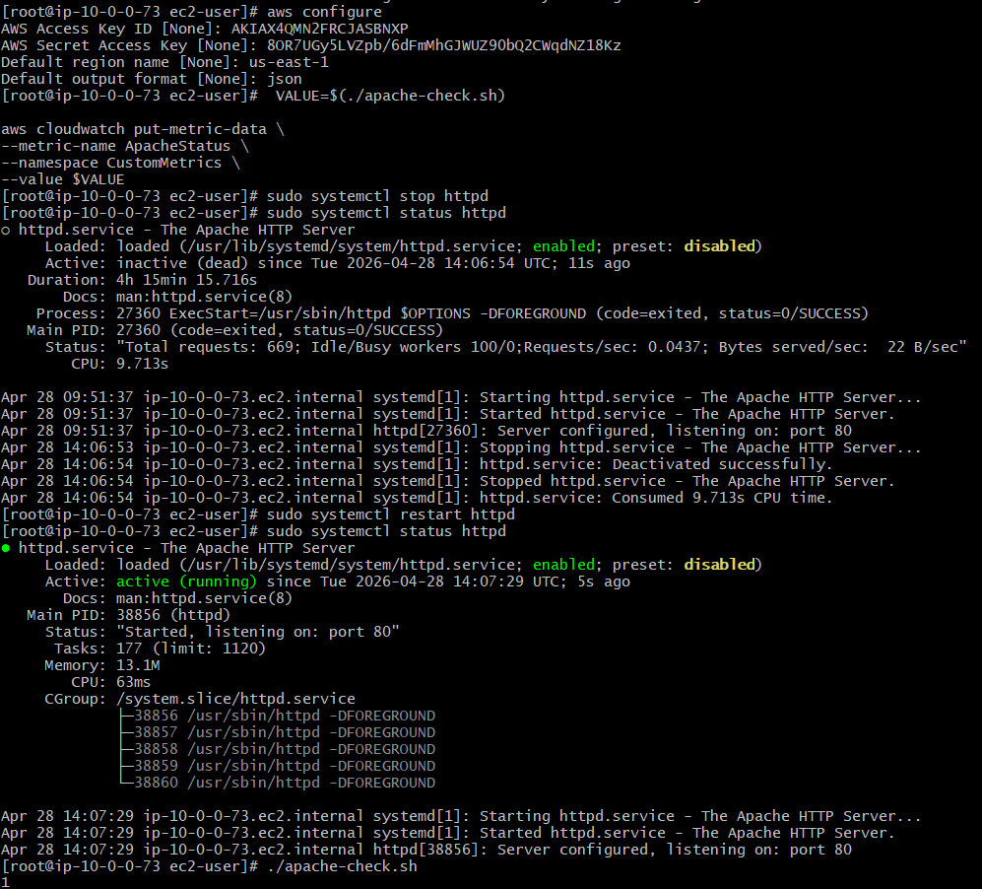
- If CPU utilization is more than 70%, then it should trigger auto scaling and launch new instance.
- By Using the EC2 launch template a template has been created.
- Created new Auto scaling group
- Two new desired instances created default after giving desired -2, mini-1, max-4
- In Auto scaling group by selecting open it and in that activity we can see
- After terminated the default ec2 and we can see new instance created in instance
- After giving more load on CPU utilization, we can see new instances created
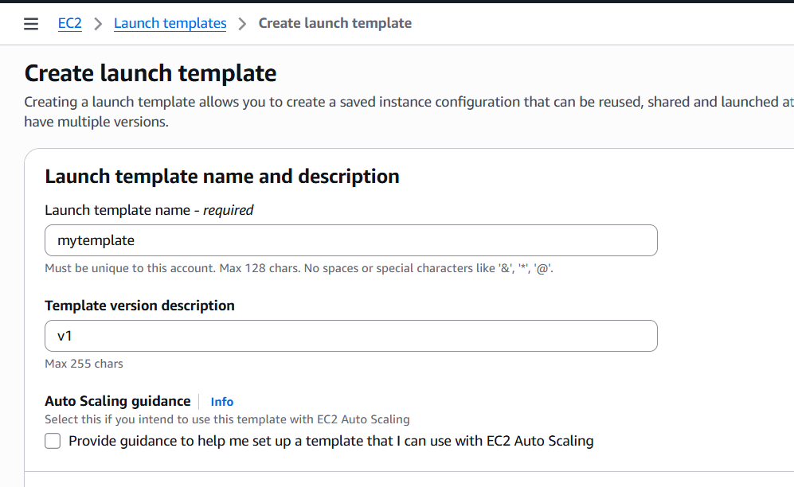
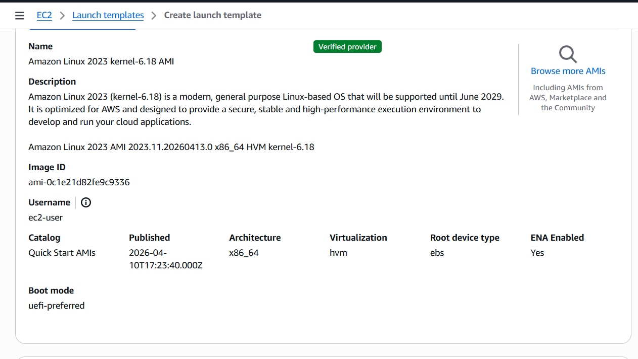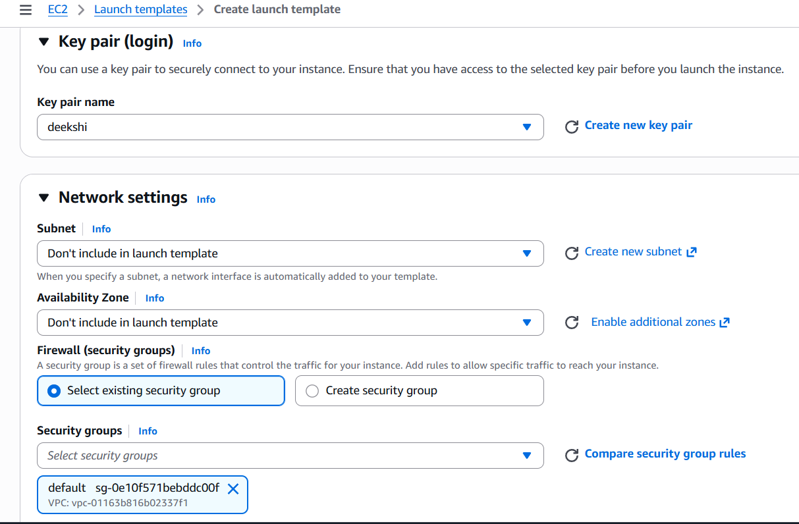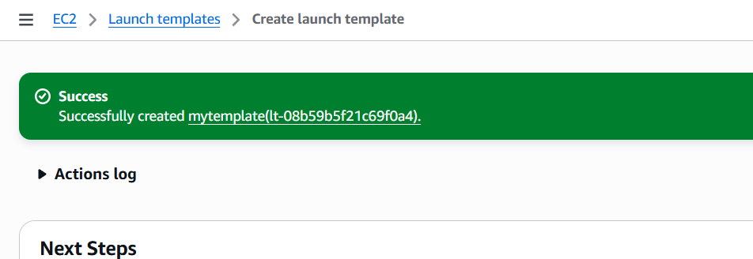
Auto scaling group launch template instance launch options integrate with other→
options configure group size add notifications add tags create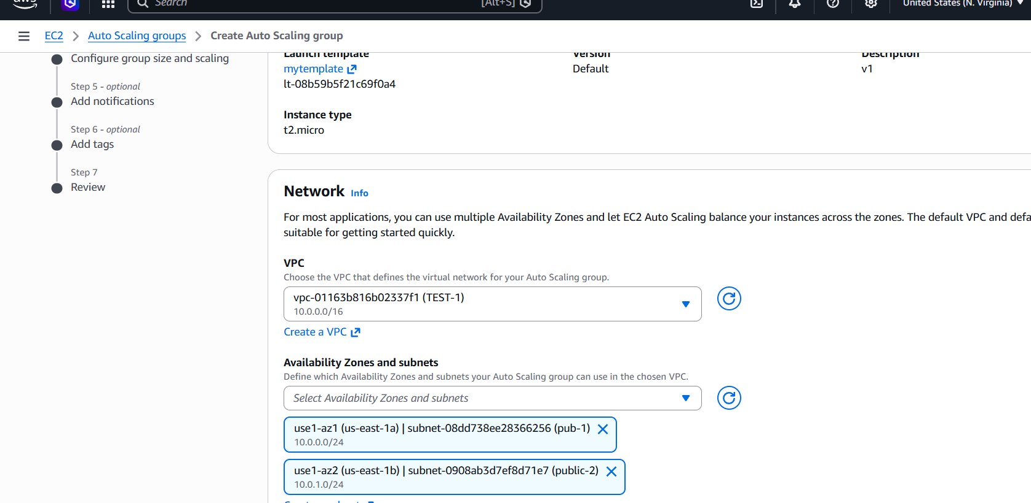
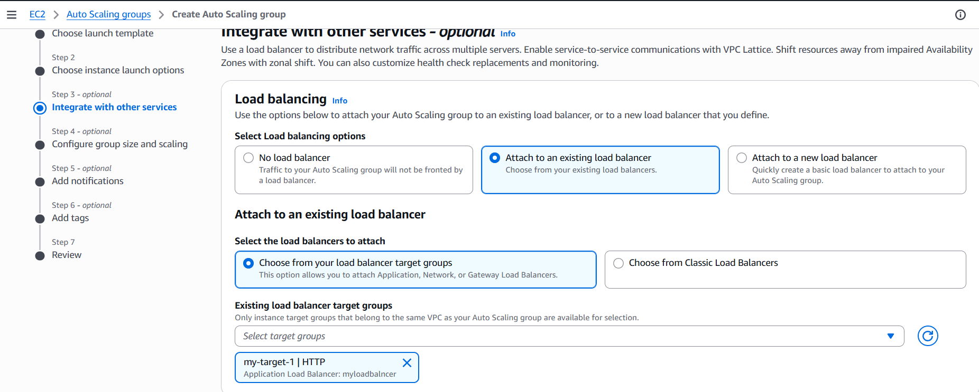
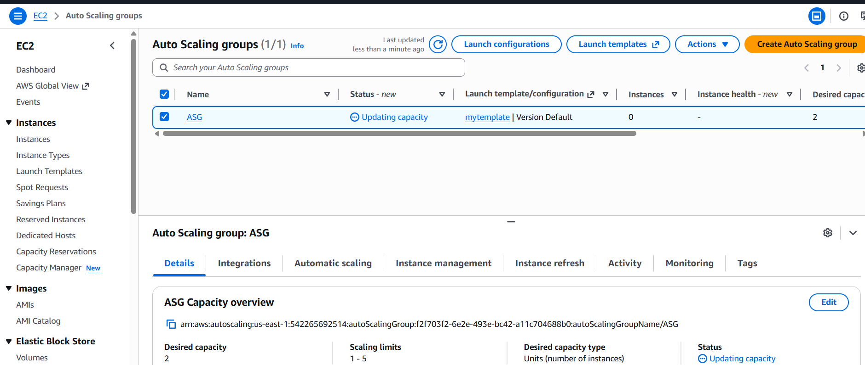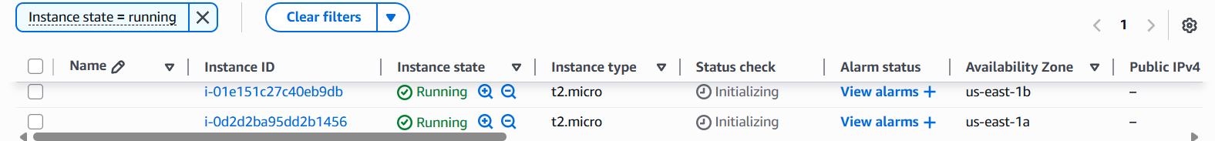
- As i terminated the two instances it created a new instance
- As the cpu utilization has crossed the threshold value it has been started to create new
instances.
- yes > /dev/null & using this command we can increased the cpu utilization.
- We can see in Auto Scaling Group
